**Ideation Phase**

**Empathize & Discover**

|  |  |
| --- | --- |
| Date | 30-06-2025 |
| Team ID | LTVIP2025TMID43096 |
| Project Name | Flight Finder: Navigating Your Air Travel Options |
| Maximum Marks | 4 Marks |

**Empathy Map Canvas:**

An empathy map is a simple, easy-to-digest visual that captures knowledge about a user’s behaviours and attitudes.

It is a useful tool to helps teams better understand their users.

Creating an effective solution requires understanding the true problem and the person who is experiencing it. The exercise of creating the map helps participants consider things from the user’s perspective along with his or her goals and challenges.

**Example:**

Reference: <https://www.mural.co/templates/empathy-map-canvas>

**Example: Food Ordering & Delivery Application**

**Empathy Map Overview: Customer, Admin & Flight Operator:**

In the Flight Booking MERN application, empathy maps help us understand the needs of Customers, Admins, and Flight Operators. Customers think about finding affordable flights quickly, feel anxious about delays, see clear options, and book with ease .They need a smooth, reliable experience that builds trust and confidence while managing their journeys.  
Admins think about system stability, feel responsible for secure operations, see user activity, and act to manage roles and data .They require powerful tools to oversee users, flights, and bookings with full control.  
 Flight Operators think about schedule accuracy, feel the pressure real time updates , see flight data, and manage flight entries .They rely on a clean, responsive dashboard to maintain and update flight details efficiently . Using empathy mapping ensures we design features based on what each role thinks, feels, sees, and does. Overall, empathy-driven design enhances usability, trust, and task completion for every role in the system.

**Empathy Map for Flight Finder: Navigating Your Air Travel Options:**

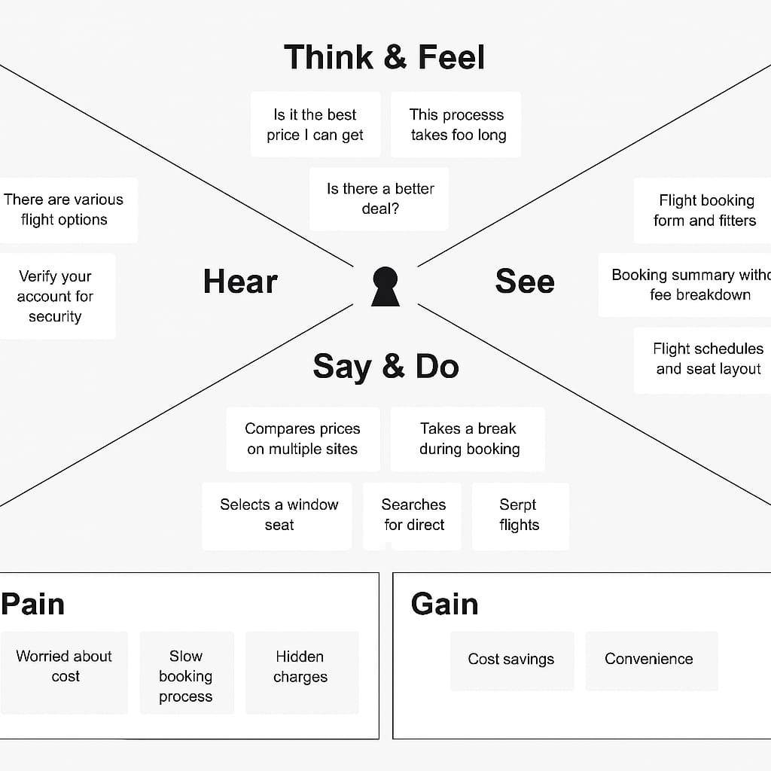

Customers think about finding affordable flights quickly, feel anxious about delays, see clear options, and book with ease.  
They need a smooth, reliable experience that builds trust and confidence while managing their journeys.  
Admins think about system stability, feel responsible for secure operations, see user activity, and act to manage roles and data.  
They require powerful tools to oversee users, flights, and bookings with full control.  
Flight Operators think about schedule accuracy, feel the pressure of real-time updates, see flight data, and manage flight entries.  
They rely on a clean, responsive dashboard to maintain and update flight details efficiently.  
Using empathy mapping ensures we design features based on what each role thinks, feels, sees, and does.  
This approach improves user satisfaction by aligning the interface with their real-world concerns and behaviors.  
Overall, empathy-driven design enhances usability, trust, and task completion for every role in the system.